Parents are able to connect to their students’ accounts by “pairing.” **This is something that parents will have to do**, there is no automated process.

1. I recommend that parents download the Canvas Parent app since they will most likely engage with Canvas from their phones. This will also allow them to receive notifications on their phones. Therefore, I would ask the parents to first download the parent app. It is free.

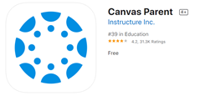

1. The student will log into his/her Canvas account through Launchpad. Once in Canvas, they will click on their account (circle with silhouette or photo) and click **QR for Mobile Login.** This will generate a QR code that is valid for 10 minutes. The parent can scan the QR code from their Canvas Parent app. This will take the parent directly to the student’s page.

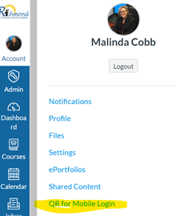

1. Next, the parent will be asked for the student’s pairing code. From the student’s account, the student will select Settings (see image above). In the Settings, there will be a button on the right side of the page called **Pair with Observer**. When the user presses this button, it will generate a short pairing code. The parent will enter this code in the app. The parent only has to do this process once for the child’s educational career (K-12).

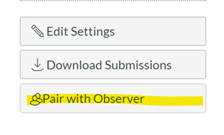

1. That’s it. The parent and student are now paired. They can repeat the same steps with pairing codes to add additional children if needed.
2. For directions using a Desktop or Laptop for pairing, please [click here](https://www.rcboe.org/cms/lib/GA01903614/Centricity/Domain/15556/ParentLoginforCanvas.pdf). Parents will need to search for **RCBOE Parents** in the menu.